Spongebob Squarepants

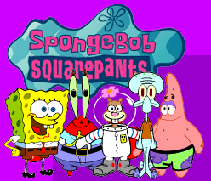
SpongeBob SquarePants premiered on Nickelodeon on July 17, 1999.

So strange, so unique, so...uh...spongy. Deep down in the Pacific Ocean in the subterranean city of Bikini Bottom lives a square yellow sea sponge named SpongeBob SquarePants. SpongeBob lives in a pineapple with his pet snail, Gary, loves his job as a fry cook at the Krusty Krab, and has a knack for getting into all kinds of trouble without really trying. When he's not getting on the nerves of his cranky next door neighbor Squidward, SpongeBob can usually be found smack in the middle of all sorts of strange situations with his best buddy, the simple yet lovable starfish, Patrick, or his thrill-seeking surfer-girl squirrel pal, Sandy Cheeks. In Bikini Bottom, fish walk, blowing bubbles is art, and the tastiest undersea treat is a deep-fried Krabby Patty Burger. Dive in and soak it all up with SpongeBob!

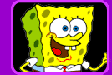
SpongeBob SquarePants
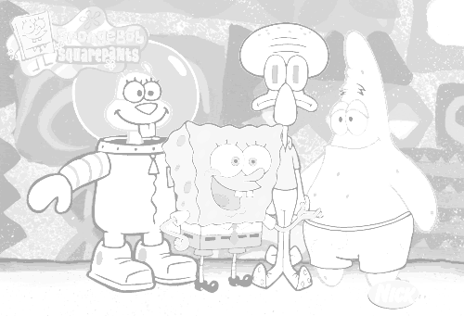
SpongeBob is a sea sponge who lives with his pet snail, Gary, in a fully furnished, two bedroom...pineapple, and has an unusual love for his job as a fry cook at the Krusty Krab. SpongeBob is as optimistic, earnest, and well-meaning as a sea-dwelling sponge gets, but despite his best intentions, he can't seem to avoid creating problems for himself--and usually everyone else around him, too. While trying too hard, he tends to do things wrong--really wrong--which often spells disaster. But SpongeBob can't help looking on the bright side of life, and his positive outlook and enthusiasm about just about everything make him downright irresistible


Patrick Star
Patrick is SpongeBob's neighbor and best friend, and his big ambition in life can be summed up in four words: "uh...I...uh...forget." As SpongeBob's closest pal, Patrick is always offering his advice and encouragement. Unfortunately, Patrick's not exactly the brightest starfish in the sea (if you catch our drift), and he usually ends up helping SpongeBob into a heap of trouble. Even their simplest plans end in disaster. But for better or worse, Patrick will always be SpongeBob's loyal buddy.

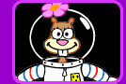
Sandy Cheeks
Sandy Cheeks is a sea dome-dwelling squirrel who lives for action and adventure. Having attempted just about every death-defying stunt under the ocean, she's accepted the ultimate challenge: living underneath it in an oxygen-filled dome. Sandy is Bikini Bottom's only resident rodent, and the apple of SpongeBob's eye (the only thing under the sea he likes better than his job at the Krusty Krab). For Sandy, SpongeBob is the sea bottom's best stunt buddy, and when they get together, crash helmets and parachutes are usually required.

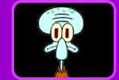
Squidward Tentacles
Squidward is a mean, whiny, stick-in-the-mud squid who thinks he's better than everyone else. Just about everything annoys him. The Krusty Krab annoys him. The customers annoy him. The boss annoys him. But most of all, SpongeBob annoys him--almost 24 hours a day. Besides working side by side with SpongeBob at the Krusty Krab, Squidward is SpongeBob's nextdoor neighbor. If it weren't for the fact that SpongeBob is the only one who likes listening to his clarinet playing, Squidward would have nothing to do with him. SpongeBob, on the other hand, thinks the two of them are the lunch shift dream team.

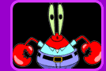
Mr. Krabs
Mr. Krabs is SpongeBob's boss and the owner of The Krusty Krab. Making money is what it's all about for Mr. Krabs, and he can usually be found in his office counting his cash and adding up the day's receipts. Although SpongeBob gets on his nerves, Mr. Krabs likes that he's willing to work long hours for little pay, and sometimes acts like his mentor. Mr. Krabs hates his fast food rival Plankton, the owner of "The Chum Bucket," but not as much as Plankton hates him. The only thing that has more control over Mr. Krabs than money is his teenage daughter, Pearl
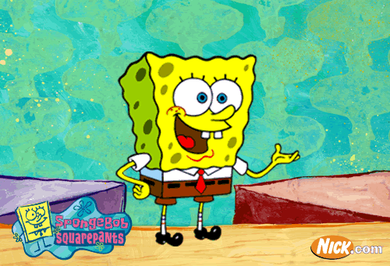

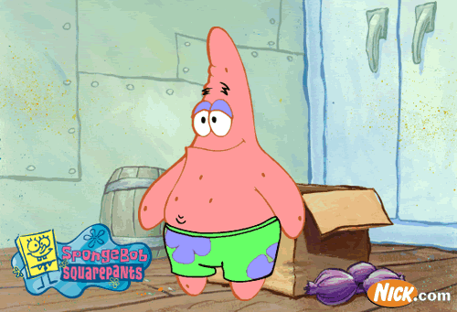

Links

Nickleodeon pages

http://www.nick.com/all_nick/tv_shows/shows.jhtml?propertyId=264&_requestid=3350589

Spongebob Squarepants Fan Club

http://www.spongebobsquarepants.net/

Double T’s Cartoon Place

http://pages.bolt.com/other/doublet/cartoons2.html

Pazsaz Entertainment Network

http://www.pazsaz.com/sponge.html

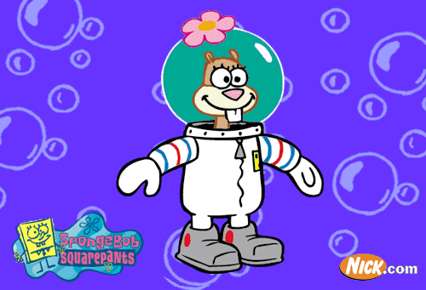

Spongebob Squarepants books at Amazon

Trivia Book (Spongebob Squarepants Humor Books)
by David Fain </exec/obidos/search-handle-url/index=books&field-author=Fain%2C%20David/102-3231162-7498508>

Joke Book (Spongebob Squarepants Humor Books)
by David Lewman </exec/obidos/search-handle-url/index=books&field-author=Lewman%2C%20David/102-3231162-7498508>
Book Description
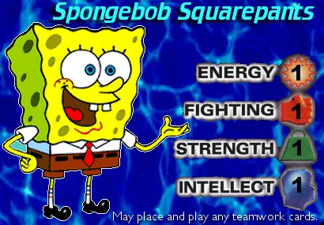
Which creature makes the best sandwiches?
The peanut-butter-and-jellyfish!
Where did the seaweed find a job?
In the "Kelp Wanted" ads.
The sidesplitting SpongeBob SquarePants Joke Book is filled with jokes that will have fans busting at the gills!

Naughty Nautical Neighbors Chapter Book #2 (Spongebob Squarepants)
by Annie Auerbach </exec/obidos/search-handle-url/index=books&field-author=Auerbach%2C%20Annie/102-3231162-7498508>, Marc O'Hare </exec/obidos/search-handle-url/index=books&field-author=O%27Hare%2C%20Marc/102-3231162-7498508> (Illustrator)
Book Description
SpongeBob and Patrick Star are the best of friends -- until their annoying neighbor Squidward decides to interfere. But Squidward's plan to split up best friends might backfire on him in a big, hilarious way!
Tea at the Treedome Chapter Book #1 (Spongebob Squarepants)
by Terry Collins </exec/obidos/search-handle-url/index=books&field-author=Collins%2C%20Terry/102-3231162-7498508>, Mark O'Hare </exec/obidos/search-handle-url/index=books&field-author=O%27Hare%2C%20Mark/102-3231162-7498508> (Illustrator)
Book Description
SpongeBob is invited to have tea with a new karate-chopping lady friend, Sandy Cheeks. But when he finds out that Sandy lives in a dome filled with air, SpongeBob's plan for a new friend might "run dry!"

Hall Monitor Chapter Book #3 (Spongebob Squarepants)
by Annie Auerbach </exec/obidos/search-handle-url/index=books&field-author=Auerbach%2C%20Annie/102-3231162-7498508>, Marc O'Hare </exec/obidos/search-handle-url/index=books&field-author=O%27Hare%2C%20Marc/102-3231162-7498508> (Illustrator)
This item will be published in November 2000.
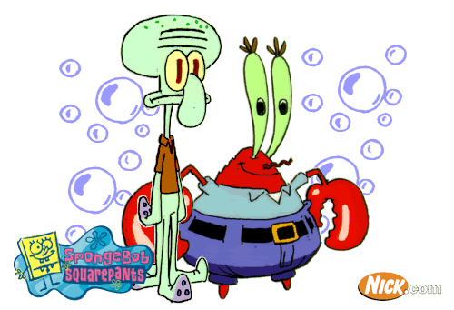

Episodes and cast list

Voice Cast:
SpongeBob SquarePants ................................. Tom Kenny
Mr. Krabs ............................................. Clancy Brown
Patrick Star .......................................... Bill Fagerbakke

Squidward Tentacles ................................... Rodger Bumpass
Sandy Cheeks .......................................... Carolyn Lawrence

Episodes
Season 1 (1999-2000)
(20 Episodes In Season 1)
Bubblestand/Ripped Pants (Originally Aired 7/17/1999)
Help Wanted/Reef Blowers/Tea At The Treedome (Originally Aired 7/24/1999)
Jellyfishing/Plankton! (Originally Aired 7/31/1999)
Naughty Nautical Neighbors/Boating School (Originally Aired 8/7/1999)
Pizza Delivery/Home Sweet Pineapple (Originally Aired 8/14/1999)
Mermaid Man & Barnacle Boy/Pickles (Originally Aired 8/21/1999)
Hall Monitor/Jellyfish Jam (Originally Aired 8/28/1999)
Sandy's Rocket/Squeaky Boots (Originally Aired 9/4/1999)
Nature Pants/Opposite Day (Originally Aired 9/11/1999)
Culture Shock/F.U.N. (Originally Aired 9/18/1999)
Musclebob Buffpants/Squidward The Unfriendly Ghost (Originally Aired 9/25/1999)
The Chaperone/Employee Of The Month (Originally Aired 10/2/1999)
Scaredy Pants/I Was A Teenage Gary (Originally Aired 10/28/1999)
SpongeBob 3000/Karate Choppers (Originally Aired 12/31/1999)
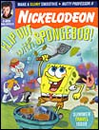
Sleepy Time/Suds (Originally Aired 1/17/2000)
Valentine's Day/Lemons Out Of Lemonade (Originally Aired 2/14/2000)
Argh!/The Bus (Originally Aired 3/18/2000)
Texas/Walking Tall (Originally Aired 3/25/2000)
April Fools/The Spatula And The Stove (Originally Aired 4/1/2000)
Hooky/25 Words Or Less (Originally Aired 4/8/2000)

